IEEE P802.11
Wireless LANs

TGac Channel Model Addendum Supporting Material

May, 2009

Authors:
Greg Breit, gbreit@qualcomm.com
Hemanth Sampath, hsampath@qualcomm.com
Sameer Vermani, svverman@qualcomm.com
Richard Van Nee, rvannee@qualcomm.com
Minho Cheong, minho@etri.re.kr
Naoki Honma, honma.naoki@lab.ntt.co.jp
Takatori Yasushi, takatori.yasushi@lab.ntt.co.jp
Yongho Seok, yhseok@lge.com
Seyeong Choi, seyeong.choi@lge.com
Phillipe Chambelin, philippe.chambelin@thomson.net
John Benko, john.benko@orange-ftgroup.com
Laurent Cariou, laurent.cariou@orange-ftgroup.com
VK Jones, vkjones@qualcomm.com
Allert Van Zelst, allert@qualcomm.com
Lin Yang, linyang@qualcomm.com

Abstract

This document provides background material for the addendum to TGn channel model document (IEEE802.11-09/0308r3) to be used for the Very High Throughput Task Group (TGac).

Revision History

Date | Version | Description of changes
05/xx/09 | 1.0 | Derived from earlier draft of channel model addendum 09/0308r2. Maintains supporting material removed from r3 of that doc.

Introduction

The TGn task group has developed a comprehensive MIMO broadband channel models, with support for 40 MHz channelization and 4 antennas. The TGac task group is targeting > 1 Gbps MAC SAP throughput using one or more of the following technologies:
- Higher order MIMO (> 4x4)
- Higher Bandwidth (> 40 MHz)
- Multi-User MIMO with > 4 AP antennas
- OFDMA
In this document we propose some simple modifications to TGn channel models to enable their use for TGac with accompanying supporting simulations and measurement data..

Modifications for Larger System Bandwidth

The TGn channel models assume minimum tap spacing of 10 ns and were employed for system bandwidth of up to 40 MHz. TGac systems may have much larger bandwidth. For TGac systems with larger overall system bandwidth, we propose to increase the channel sampling rate and decrease channel tap spacing by a factor of 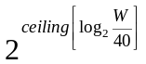, where W is the new system bandwidth in MHz. These scaling factors are summarized in Table 1.
Note that since the interpolated taps provide different frequency diversity, fundamentally they are different channels. Hence, for development work going forward, it is recommended to state explicitly whether simulations are based on TGn or TGac versions of the channel models.

Table 1: Channel sampling rate expansion (tap spacing reduction) factors
System Bandwidth W | Channel Sampling Rate Expansion Factor | Channel Tap Spacing
W ≤ 40 MHz | 1 | 10 ns
40 MHz < W ≤ 80 MHz | 2 | 5 ns
80 MHz < W ≤ 160 MHz | 4 | 2.5 ns
W > 160 MHz | 8 | 1.25 ns

We propose to reduce tap spacing by generating new taps based on linear interpolation of the TGn-defined channel tap powers on a cluster-by-cluster basis using the following approach:
For each cluster in the TGn-defined model, and assuming a channel sampling rate expansion factor k (new sampling rate = k*100MHz), a sequence of k-1 new taps, spaced 10/k ns apart, shall be appended after each TGn-defined tap. The first tap in the sequence shall occur 10/k ns after the TGn-defined tap. The power assigned to each new tap shall be determined by dB-linear interpolation of the TGn-defined tap powers immediately before and after the new tap, in proportion to its position in time relative to the two TGn taps. No new taps shall be added after the final TGn tap for each cluster.
Figure 1 illustrates this procedure for the example of k=4 (new channel sampling rate = 400MHz), for a hypothetical pair of TGn-defined taps spaced 20ns apart. The TGn taps are denoted by the thick grey arrows, and the new interpolated taps are denoted by the thin black arrows. In this case, 3 new taps are added 2.5ns, 5.0ns, and 7.5ns after TGn Tap i. Power for each of the new taps is derived from the line connecting the power of the TGn Taps i and i+1, which accomplishes the dB-proportional power interpolation described above. This procedure is performed for all TGn Taps i for i=1 to (n_taps-1), where n_taps is the number of taps in the cluster being interpolated.

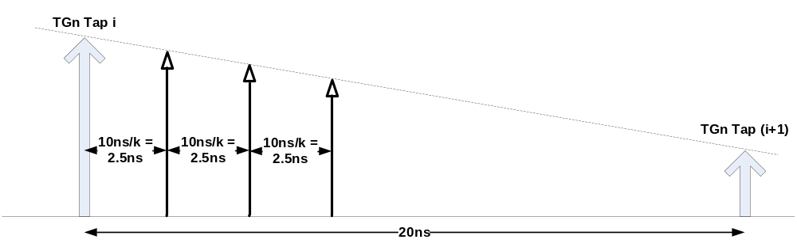
Figure 1: Illustration of tap interpolation scheme for channel bandwidth expansion

Validation

To validate the proposed interpolation scheme, we assess the difference between the existing TGn channel and the interpolated TGac channel in terms of delay spread, Ricean K factor, and link performance.
The proposed scheme was applied to interpolate TGn Models B-F from 20MHz to 80MHz bandwidth. The RMS delay spreads (in ns) of the 20MHz non-interpolated (TGn) and 80 MHz interpolated (TGac) channels were calculated and are presented in Table 1. These results demonstrate that the proposed interpolation scheme produces good RMS delay spread agreement with the original non-interpolated model.

Table 2: RMS delay spread (ns) of TGn and interpolated TGac channel models
 | B | C | D | E | F
11n | 15.648 | 33.433 | 49.953 | 98.990 | 148.92
11ac | 15.933 | 33.278 | 49.402 | 97.249 | 142.14

shows the median Ricean K factor calculated from 1600 random instances of each LOS channel model for both the original TGn channel and the 80MHz interpolated TGac channels. The frequency domain channel was converted to time domain by IFFT and the K factor estimation method of Greenstein et al was applied to the first time domain tap of each instance. These results demonstrate that channel bandwidth expansion by tap interpolation does not bias the K factor of the resulting modeled channels.

Table 3: Ricean K factor (linear) of TGn and interpolated TGac channel models. Values in parentheses are the target K value specified for each model
 | B  (K=1) | C  (K=1) | D  (K=2) | E  (K=4) | F  (K=4)
11n | 0.986 | 1.031 | 2.036 | 4.087 | 3.980
11ac | 1.012 | 1.048 | 1.912 | 3.873 | 4.060

To further validate the tap interpolation scheme, a series of simulations was performed, comparing link performance between TGn and interpolated TGac channels for the case of Example 2 above. Table 2 compares performance between TGn and the interpolated TGac channel for models B-F NLOS, assuming 1x1 40 MHz transmission at data rate 108 Mbps (64QAM, 2/3), and perfect timing and frequency estimation. The values shown the table represent the difference in SNR required to achieve the stated PER.
Table 4: Link performance comparison between TGn and interpolated TGac channel models. Values represent dB difference in required SNR to achieve 1% and 10% PER
 | B | C | D | E | F | F (QPSK ¾)
PER=10% | 0.1 | 0.0 | 0.0 | 0.0 | 0.25 | 0.0
PER=1% | 0.1 | 0.2 | 0.05 | 0.1 | 1.0 | 0.5

For Models B-E, there was very good agreement between the two models, with negligible performance differences (≤0.2 dB) at both 10% and 1% PER. Disagreement was larger for Model F at PER=1%, (1.0 dB for 64QAM 2/3, and 0.5 dB with QPSK 3/4). We attribute this difference to the fact that the Model F PER curves are flooring, combined with the slightly altered frequency diversity introduced by the interpolated taps.

Higher Order MIMO

The TGn channel models were originally conceived for systems with 4x4 MIMO, and are based on the Kronecker channel correlation model assumption [4]. We investigated whether the Kronecker models are also sufficient to reasonably predict performance in realistic environments. We propose that it is sufficient for channel models to tightly bound and sweep the range of performance in real environments. Furthermore, it is desirable that the channel model is simple enough and builds on TGn channel models to allow a fair and efficient comparison of different standards proposals.
Figure 1 show CDFs of PHY capacity for several simulated and measured 8x8 MIMO channels assuming 20dB average SNR. In this figure, capacity is calculated as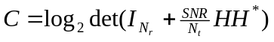, where SNR is the average receive Signal-to-Noise ratio, N_{r} and N_{t} are the number of receive and transmit antennas respectively, and ‘*’ denotes the Hermitian transpose.
The topmost plot in Figure 1 shows performance curves depicting capacity of 30 8x8 channels measured in an indoor office environment at 5 GHz using λ/2-spaced linear dipole arrays at the transmitter and receiver [1]. Red curves represent measurements made in NLOS conditions. Blue curves represent an LOS measured channel with approximately 5m separation between transmitter and receiver. Green curves represent LOS measurements made down a long corridor, with 20-40m separation between TX and RX. Corresponding capacity of an i.i.d. channel is provided for comparison.
The thick performance curves in the center and bottom plots in Figure 1 respectively show results for TGn Model D and Model B, extended to eight antennas. The center and bottom plots also show channel capacity CDFs of the extended 8x8 TGn model results obtained by randomly rotating the TGn defined cluster AoA and AoDs to emulate the case-by-case variation expected in real-world environments. To generate these curves, random offsets distributed uniformly between ±180° were added to each cluster AoD and AoA.
The capacity range spanned by the model curves agrees well with the measured channels, especially for Model D, which most closely emulates the small-office environment in which the measurements were performed.

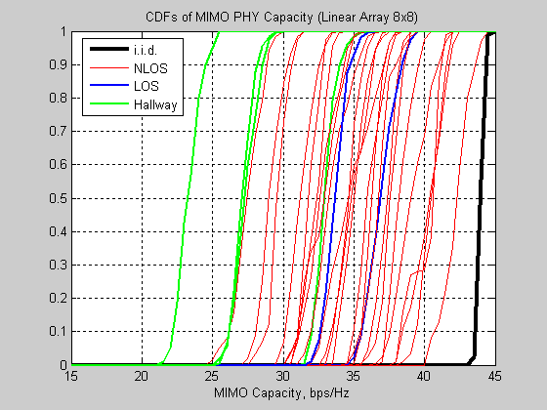
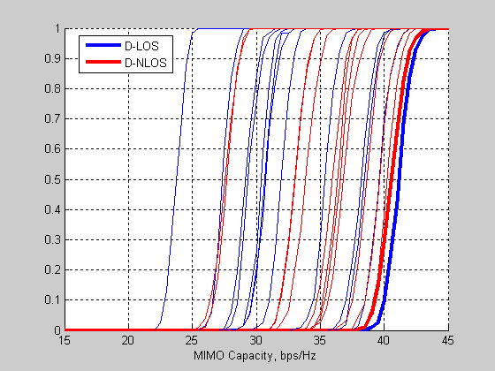
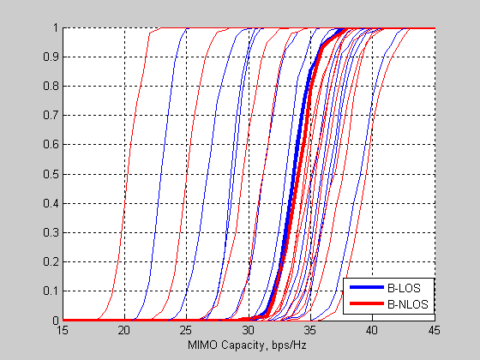
Figure 2: CDFs of MIMO channel capacity. Top: Results of 30 indoor channel measurements in NLOS and LOS conditions, including propagation down a long hallway. Center: TGn Model D (thick lines) plus multiple model instances using randomly offset cluster AoAs and AoDs (thin lines). Bottom: TGn Model B (thick lines) plus multiple model instances using randomly offset cluster AoAs and AoDs (thin lines).

Figure 2 shows capacity results for the same channels as Figure 1, but in this case, capacity is calculated from post-processing SINR after using an MMSE receiver. The post processing SINRs were calculated for each stream and subcarrier and the PHY capacity for each stream/subcarrier calculated as log₂(1+SINR). For each instance, sum-average channel capacity was calculated by averaging across subcarriers and summing across spatial streams.
Most of the measured results fall between the curves generated from the extended TGn models. The NLOS measured data which are comparable to the worst-case Model B results were all collected in strongly directional channels, with the receive array oriented in the “end-fire” orientation with respect to the dominant cluster (AoA=90° for the dominant cluster), which is pessimistic compared to the TGn-defined cluster AoAs and AoDs.
Based on the generally good agreement between the extended TGn Channel Model D and channel measurements in LOS and NLOS indoor enterprise (small office) environments, we propose to re-use the Kronecker channel model for 8x8 MIMO.

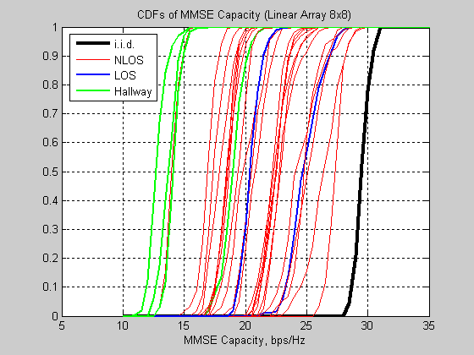
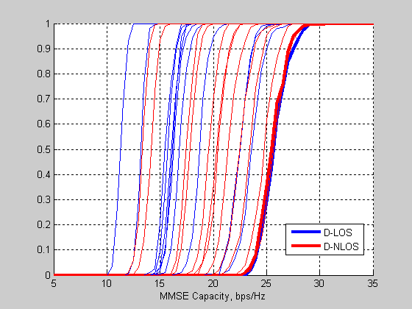
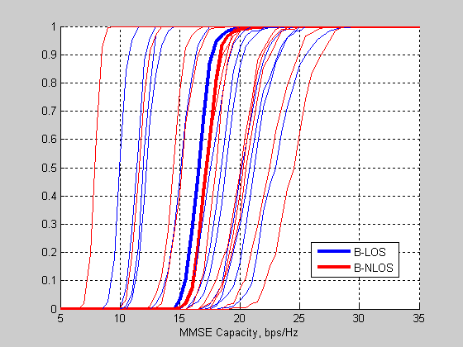
Figure 3: CDFs of MMSE channel capacity. Top: Results of 30 indoor channel measurements in NLOS and LOS conditions, including propagation down a long hallway. Center: TGn Model D (thick lines) plus multiple model instances using randomly offset cluster AoAs and AoDs (thin lines). Bottom: TGn Model B (thick lines) plus multiple model instances using randomly offset cluster AoAs and AoDs (thin lines).

Modifications to AoA and AoD for Multi-User MIMO with up to 16 AP antennas

Motivation

TGac requires specification of channels to multiple users as simultaneous communication will take place to multiple STAs in technologies like multi-user MIMO. The TGn channel model document specifies the cluster AoAs and AoDs for point-to-point single user transmissions. Extensions of these AoDs and AoAs to the multi-user case are needed.

Physical Reasoning

In [5], it is shown that for the same receiver location, different transmitter locations lead to a different AoA at the receiver. Specifically, the measurements report that clusters AoA vary by 0-20 degrees in NLOS scenario (classroom) and 0-60 degrees in LOS scenario (great hall), depending on location. This is equivalent to a multi-user MIMO scenario with a fixed transmitter location and receivers at different locations. Based on the results shown in [5], we conjecture that for the same transmitter location, different receiver locations lead to a different AoD at the transmitter.
However, from a physical point of view, it is clear that if all the scatterers in the channel are very close to the AP, then the AoD will be similar regardless of STA location or orientation, as illustrated in Figure 4.

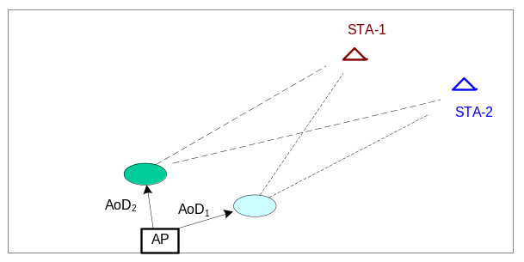
AP may have a similar AoDs for clusters regardless of transmission to STA-1 or STA-2
Scenario: NLOS channel with scatterers close to AP
Figure 4: NLOS channel with scatterers very close to the AP

However, not all scenarios fall in this category. In LOS channels, as shown in Figure 5, AoDs for the main LOS component (and the resulting steering vectors) will be different for different clients. Enforcing identical AoDs in this case is not physically realistic. In fact, such a restriction will “break” multi-user transmission in pure LOS scenarios if the steering vectors are deemed identical.

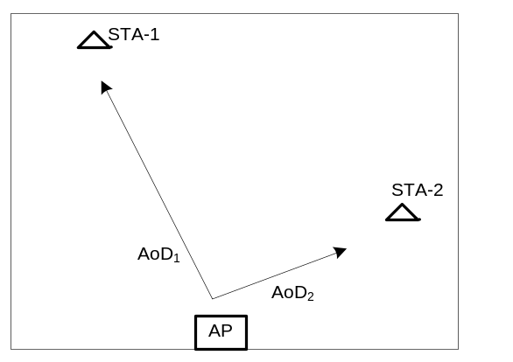
From Physics, AP has a different AoD to STA-1 and STA-2. This implies that, the LOS steering vectors to STA-1 and STA-2 are different
Scenario: Pure LOS channel
Figure 5: A typical depiction of a pure LOS scenario

Furthermore, there will be scenarios where not all clusters are close to the AP, or where different clusters will be relevant to different clients as can be seen in Figure 6 below. This is supported by the findings in [5] where the authors show that some clusters are relevant for one location, whereas absent in other locations. Enforcing identical AoD in this case will unrealistically lower SDMA capacity.
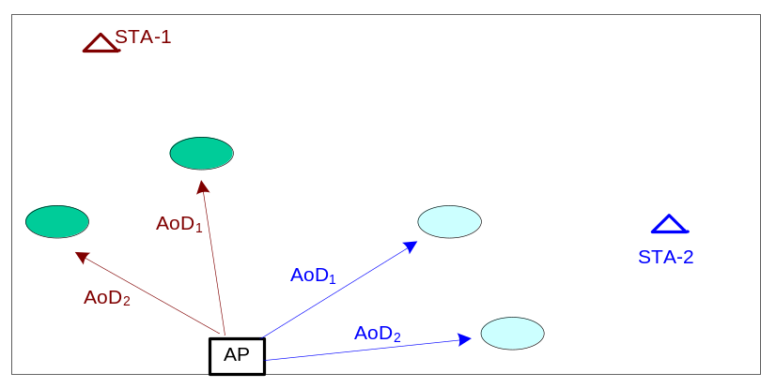
Different scatterers may be relevant to different STAs. This would imply that AP may have a different AoDs for clusters corresponding to STA-1 and STA-2
Scenario: NLOS channel with scatterers far away from AP
Figure 6: A typical NLOS situation where scatterers are far away from the AP

TGac Modifications
We assume TGn-defined cluster AoDs and AoAs as baseline and make the following modifications to the AoA and AoD for each client:
- A single pseudo-random offset is added to all cluster AoDs and AoAs.
  - Assuming a “pseudo-random” offset selection allows a quick and fair comparison across proposals, by ensuring all proposals use identical AoA/AoDs across clients. Note also that using a single AoA/AoD offset retains TGn angular spacing between clusters.
- The NLOS Cluster AoD offsets are uniformly distributed between ±TBD°.
  - This is based on the experimental results obtained in [5], and also strives to achieve a compromise on the physical scenarios outlined earlier in the section.
- The NLOS Cluster AoA offsets are uniformly distributed between ±180°.
  - This is because each client will experience independent AoA depending on its orientation and location.
- The LOS tap AoA and AoD offsets are uniformly distributed between ±180°.
  - This is because the direct LOS path to each client can have independent AoA/AoD depending on its location relative to the AP.

There are several advantages of the above TGac modifications. First, the model is physically realistic and can be realized via a simple modification to the TGn channel model. Secondly, MU-MIMO to each distinct set of clients results in a different capacity performance due to the statistical variation of AoA/AoD across clients. The simulation complexity increase in the TGac channel model is also reasonable since the Transmit and Receive antenna correlation matrices need only be computed once per client for the entire simulation run.

Justification for different AoDs through performance simulations

Physical arguments alone are not sufficient to justify adding complexity to the existing TGn channel model. The additional complexity is justified only if there is a significant impact on system performance by assuming unequal AoDs. To investigate these further, simulations were performed to evaluate sensitivity of SDMA channel capacity to unequal AoD among users. Below we list the assumptions and the scenarios under which we perform the simulations.
- Assumptions:
  - 16 TX antennas, 8 STAs, 2 RX antennas per STA
  - TGn channel models B, D (LOS and NLOS scenarios) used as baseline
    - AoD and AoA as specified in the TGn channel model document
  - Composite multi-user channel matrix constructed from vertical concatenation of 8 2x16 channel matrices
    - Clients are effectively uncorrelated from each other
- Scenarios:
  - TGn-defined cluster AoDs and AoAs used for all clients
  - For each client, a random offset is added to cluster AoDs and AoAs (all cluster angles for a single client are rotated by the same amount)
    - NLOS cluster AoD offsets are uniformly distributed between ±30°
    - NLOS cluster AoA offsets are uniformly distributed between ±180°
    - LOS tap AoA/AoD offsets are uniformly distributed between ±180°

Channel Capacity Analysis
For each random scenario, we generate 200 composite channel realizations. For every channel realization, on each sub-carrier, an MMSE precoding matrix [6] is calculated based on the per-tone channel H as:
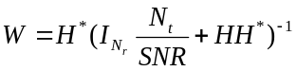,

where 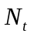 = 16 is the number of transmit antennas, 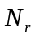 = 16 is the total number of spatial streams in the transmission (number of users, 8, times the number of spatial streams per user, 2), 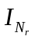 is the identity matrix of size . By SNR, we denote the total transmit power divided by the noise variance at each of the receive antennas. We assume this number to be 20 dB for our simulations. The precoding vector for a spatial stream is given by the corresponding normalized column of . Also, we make an assumption of assigning equal power to all spatial streams, allowing us to use the post processing SINR expression given in [6]. For further details on the MMSE formulation and the SINR expression used, the reader is referred to [6]. The post processing SINRs were calculated for each stream on every subcarrier and the PHY capacity for each stream/subcarrier was calculated as log₂(1+SINR). Sum-average channel capacity is then determined for each channel realization, by averaging this number across sub-carriers, and adding across spatial streams. Finally, a CDF of sum-average capacity is generated across the 200 channel instances.
Figure 6 below shows capacity CDFs for the two scenarios based on TGn Channel Model B. In each case, the thick black curve represents Scenario 1, where all clients use the same AoA and AoD, while the thin curves represent ten independent instances of Scenario 2, where each client uses an AoA and AoD offset from the TGn definitions by a fixed random amount as described above. In LOS conditions, capacity improves by 20% when different per-client AoDs and AoAs are assumed, depending on the chosen angular offsets. The principal mechanism for this capacity improvement is because (a) the AoD variation in LOS channel component leads to variation of steering vectors across clients and (b) Cluster AoD diversity across clients leads to decrease in Tx antenna correlation, especially for model with small AS (few clusters). The improvement is less pronounced under NLOS conditions due to the absence of LOS path.
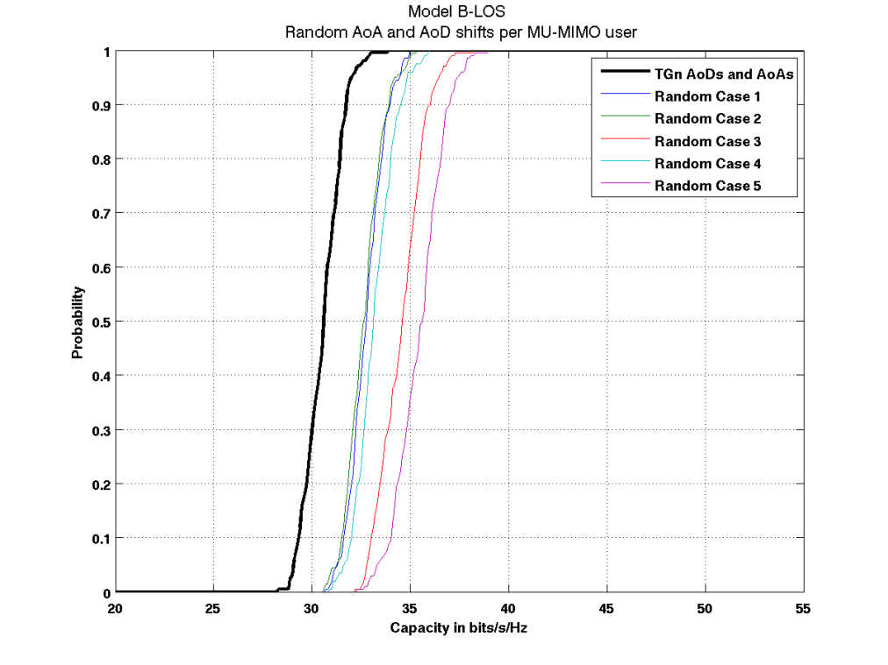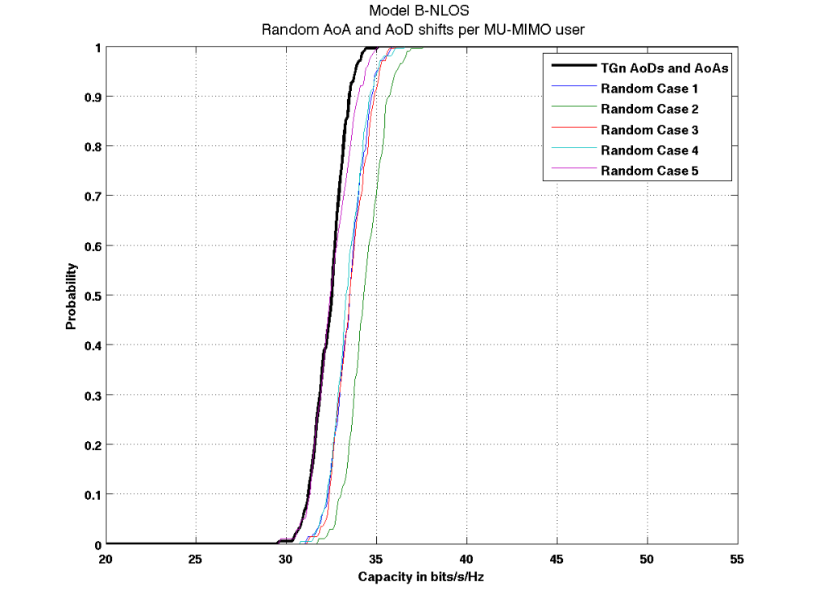
Figure 7: CDFs of modelled SDMA channel capacity, based on TGn Channel Model B (Top: LOS; Bottom: NLOS). The thick black curve represents the case where TGn-defined AoAs and AoDs are used for all clients. The thin curves show 5 different cases where random offsets from the TGn AoDs and AoAs are applied for each client.
Figure 7 shows the capacity CDFs for the two scenarios based on TGn Channel Model D. Here, the combined impact of AoA and AoD diversity seems to lead to a -10% decrease in capacity.
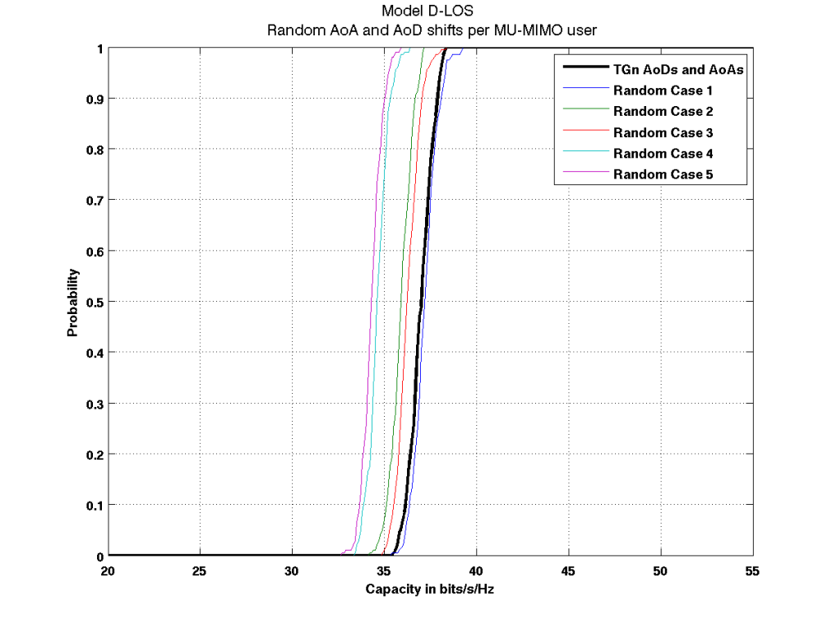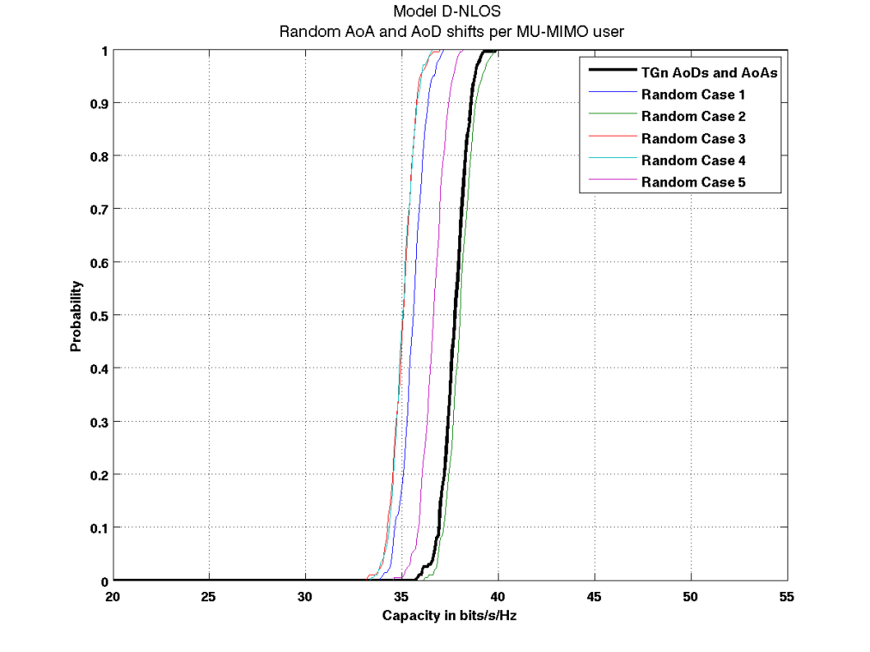
Figure 8: CDFs of modelled multi-user channel capacity, based on TGn Channel Model D (Top: LOS; Bottom: NLOS). The thick black curve represents the case where TGn-defined AoA and AoD are used for all clients. The thin curves show 5 different cases where random offsets from the TGn AoDs and AoAs are applied for each client.

This contradiction with the results of Model B is because the TGn-defined AoAs for the three Model D clusters are near-optimal in terms of RX correlation for a linear antenna array. Any common rotation of these three cluster AoAs tends to produce a less favorable RX correlation matrix for a single client. Consequently, randomly rotating these AoAs for each user in a composite multi-user MIMO channel will tend to diminish capacity compared to using the TGn values for all users. We did not observe this phenomenon for Model B, which suggests that rotating the cluster AoAs for that model has a less biased effect on RX correlation than in Model D.
Figure 8 shows the capacity CDFs for the two scenarios based on TGn Channel Model F. Here, the combined impact of AoA and AoD diversity seems to negligible change in capacity.
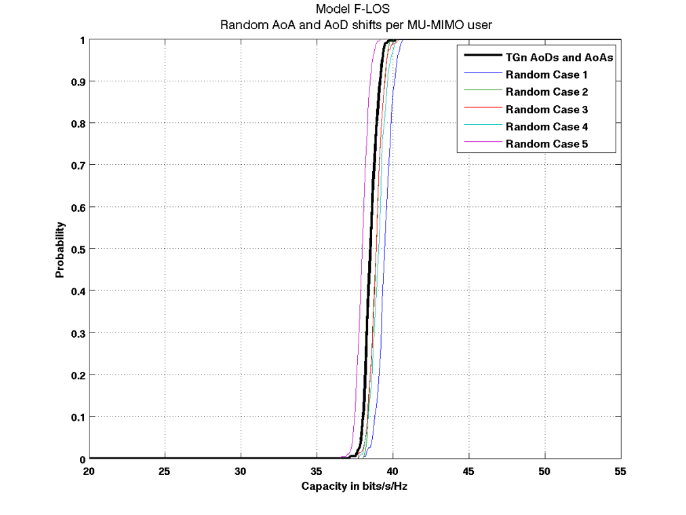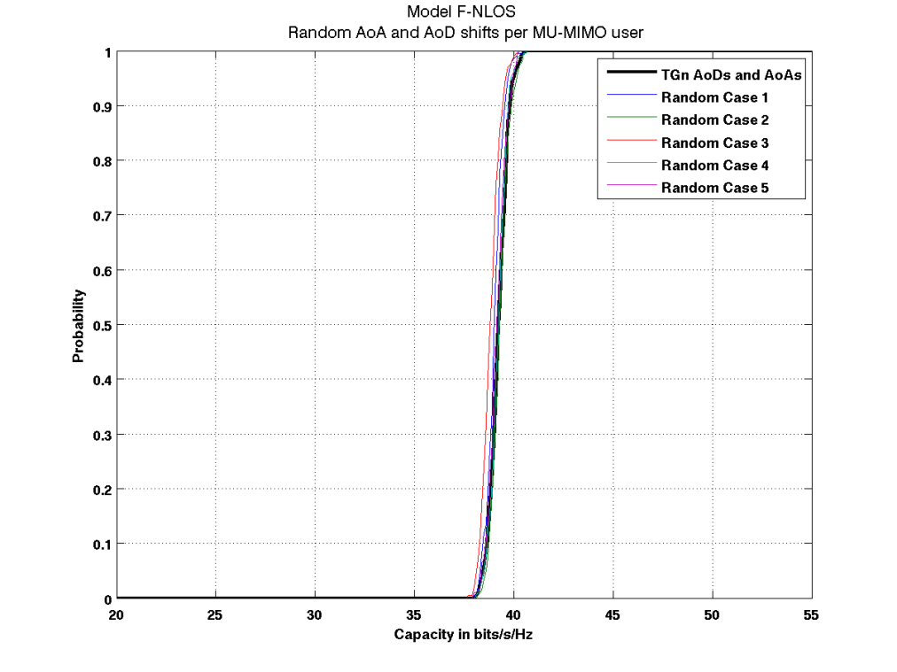
Figure 9: CDFs of modelled multi-user channel capacity, based on TGn Channel Model F (Top: LOS; Bottom: NLOS). The thick black curve represents the case where TGn-defined AoA and AoD are used for all clients. The thin curves show 5 different cases where random offsets from the TGn AoDs and AoAs are applied for each client.

This is because channel model F has 6 clusters, each with a large AS of 30-60 degrees. The net AS across all the clusters is significantly large enough to make the capacity CDF less sensitive to AoA/AoD variations.
To conclude, these results show that AoD diversity across STAs impacts multi-user MIMO performance in LOS channel models, with smaller number of clusters and smaller AS per clusters such as Channel Model B. As seen in Figure 8, AoD diversity between clients has less of an effect in channels where there is already significant angular spread, such as Model F.

Incorporating Dual-Polarized Antennas

By exploiting polarization diversity in the channel, dual-polarized antennas allow for a significant improvement in MIMO channel capacity, especially in LOS scenarios. Furthermore, co-located dual-polarized antennas can also minimize real estate in devices with large number of antennas. We believe dual-pol antennas are likely to be employed in TGac devices.
We propose to implement the polarization diversity extensions to the TGn channel model suggested in Erceg et al.:
- XPD value of 10 dB for the steering matrix H_{F}
- XPD value of 3 dB for the variable matrix H_{v}
- 0.2 correlation for co-located orthogonally-polarized antenna elements
- Zero correlation for non-colocated orthogonally-polarized antenna elements

It is important to note that for capacity analysis, modeled channels incorporating XPD should be normalized only to the norm of the co-polarized elements of the channel matrix, i.e., VPOL-to-VPOL or HPOL-to-HPOL elements. Normalization to the Frobenius norm of the entire channel matrix will fail to account for the additional path loss due to transmitting and receiving on orthogonal polarizations.

Validation

To validate the polarization diversity extensions to the channel model, we compare modeled channel capacity predictions to channel measurements using cross-polarized antennas in an 8x8 MIMO system. Extension of the model to 8x8 is accomplished as discussed in Section 3.
Figure 10 and Figure 11 depict channel measurements and simulations in a similar format and using the same capacity formulations presented in the MIMO discussion in Section 3. Channel capacity in Figure 10 is calculated using the “log-det” expression, while Figure 11 is based on the MMSE-precoded formulation. The topmost plot in each figure shows performance curves depicting capacity of 28 8x8 channels measured in an indoor office environment at 5 GHz using arrays of cross-polarized slot antennas at the transmitter and receiver. Transmitter and receiver locations are identical to the measurements depicted in Section 3. Red curves represent measurements made in NLOS conditions and blue curves represent LOS measured channels, including the hallway locations shown in Figure 10 and Figure 11. Corresponding capacity of an i.i.d. channel is provided for comparison.
The thick performance curves in the center and bottom plots of each figure respectively show results for TGn Model D and Model B, extended to four cross-polarized antenna pairs as described above. The center and bottom plots also show channel capacity CDFs of the extended 8x8 cross-pol TGn model results obtained by randomly rotating the TGn defined cluster AoA and AoDs to emulate the case-by-case variation expected in real-world environments. To generate these curves, random offsets distributed uniformly between ±180° were added to each cluster AoD and AoA. The capacity range spanned by the model curves agrees well with the NLOS and short-range LOS (blue curves) measured channels. Furthermore, although measured capacity in LOS channels is generally lower than in NLOS channels, the extreme capacity degradation observed in the hallway conditions was not seen with the cross-polarized antennas.
Based on the outcome of these results, we believe the polarization diversity extensions to the TGn channel model suggested in Erceg et al. are realistic and should be implemented in the TGac channel model.

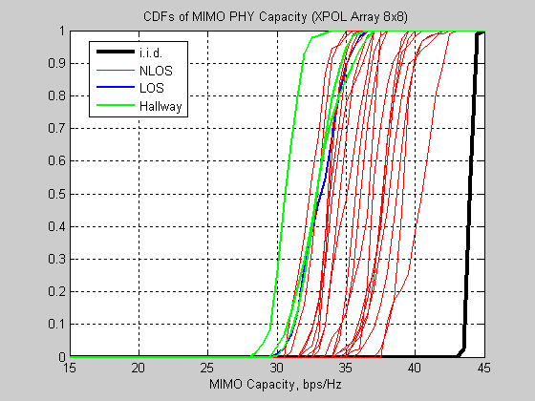
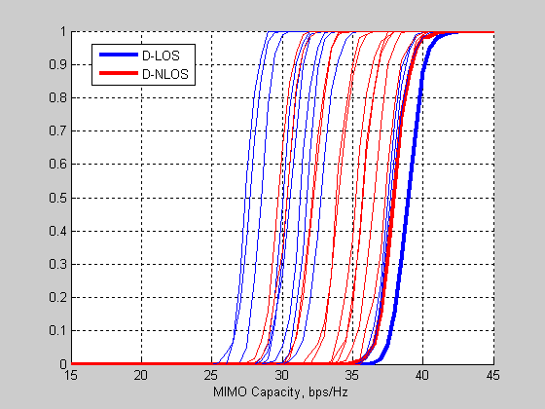
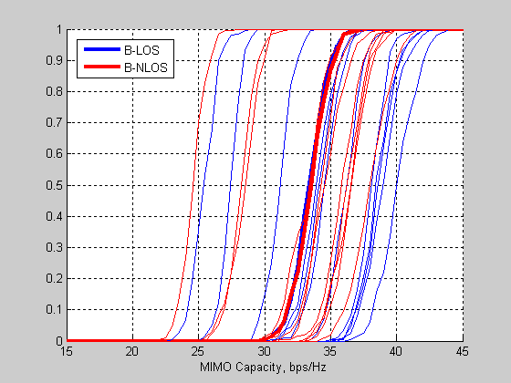
Figure 10: CDFs of MIMO channel capacity with cross-polarized antennas. Top: Results of 28 indoor channel measurements in NLOS and LOS conditions, including propagation down a long hallway. Center: TGn Model D (thick lines) with extensions for polarization diversity, plus multiple model instances using randomly offset cluster AoAs and AoDs (thin lines). Bottom: TGn Model B (thick lines) with extensions for polarization diversity, plus multiple model instances using randomly offset cluster AoAs and AoDs (thin lines).
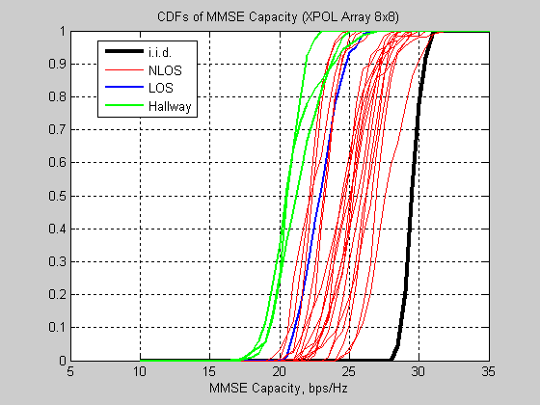
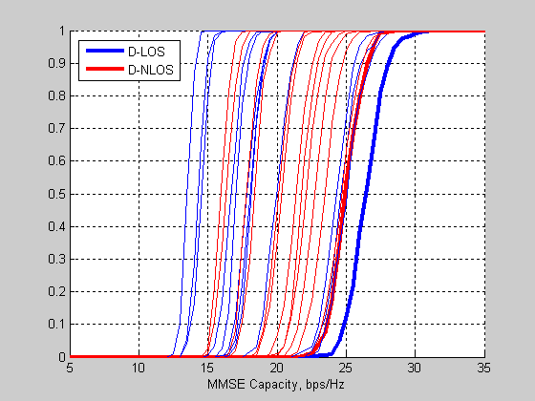
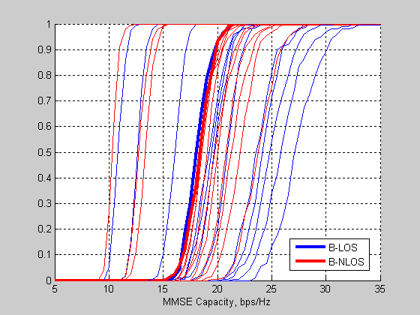
Figure 11: CDFs of MMSE channel capacity with cross-polarized antennas. Top: Results of 28 indoor channel measurements in NLOS and LOS conditions, including propagation down a long hallway. Center: TGn Model D (thick lines) with extensions for polarization diversity, plus multiple model instances using randomly offset cluster AoAs and AoDs (thin lines). Bottom: TGn Model B with polarization diversity extensions, plus multiple model instances using randomly offset cluster AoAs and AoDs.

References
- Breit, G. et al. “802.11ac Channel Modeling.” Doc. IEEE802.11-09/0088r1.
- Erceg, V. et al. “TGn Channel Models.” Doc. IEEE802.11-03/940r4.
- Kenny, T., Perahia, E. “Reuse of TGn Channel Model for SDMA in TGac.” Doc.IEEE802.11-09/0179r0.
- Schumacher, L.; Pedersen, K.I.; Mogensen, P.E., "From antenna spacings to theoretical capacities - guidelines for simulating MIMO systems," Personal, Indoor and Mobile Radio Communications, 2002. The 13th IEEE International Symposium on, vol.2, no., pp. 587-592 vol.2, 15-18 Sept. 2002.
- Jian-Guo Wang; Mohan, A.S.; Aubrey, T.A., "Angles-of-arrival of multipath signals in indoor environments," Vehicular Technology Conference, 1996. 'Mobile Technology for the Human Race'., IEEE 46th , vol.1, no., pp.155-159 vol.1, 28 Apr-1 May 1996
- Kaltenberger, F.; Kountouris, M.; Cardoso, L.; Knopp, R.; Gesbert, D., "Capacity of linear multi-user MIMO precoding schemes with measured channel data," Signal Processing Advances in Wireless Communications, 2008. SPAWC 2008. IEEE 9th Workshop on , vol., no., pp.580-584, 6-9 July 2008
- L. J. Greenstein, D. G. Michelson, and V. Erceg, “Moment-method estimation of the Ricean K-factor,” IEEE Commun. Lett., vol. 3, no. 6, pp. 175–176, Jun. 1999.

Appendix

Example bandwidth expansion scenarios

The calculation of new system bandwidth W and tap spacing is illustrated in the two examples below:

Example 1: A TGac modem with 2 channels of 40 MHz each, spaced by 60 MHz for sufficient isolation. In this case, W = 40*2+60 = 140 MHz and the channel tap spacing is reduced by a factor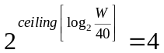, leading to an effective channel tap spacing of 2.5 nsec and channel sampling frequency of 400MHz
- Example 2: A TGac modem has 4 contiguous channels of 20 MHz each. In this case, W = 80 MHz and the channel tap spacing is reduced by a factor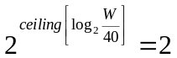, leading to an effective channel tap spacing of 5 ns and channel sampling frequency of 200MHz.

Illustration of tap interpolation

Table 5 and Table 6 illustrate the proposed tap interpolation scheme using TGn Model C as an example, and assuming a bandwidth expansion factor of 2. Error: Reference source not found

- Table 5: TGn Channel Model C, as described in [2]
 | Tap index | 1 | 2 | 3 | 4 | 5 | 6 | 7 | 8 | 9 | 10 | 11 | 12 | 13 | 14
 | Excess delay [ns] | 0 | 10 | 20 | 30 | 40 | 50 | 60 | 70 | 80 | 90 | 110 | 140 | 170 | 200
Cluster 1 | Power  [dB] | 0 | -2.1 | -4.3 | -6.5 | -8.6 | -10.8 | -13.0 | -15.2 | -17.3 | -19.5
AoA | AoA  [°] | 290.3 | 290.3 | 290.3 | 290.3 | 290.3 | 290.3 | 290.3 | 290.3 | 290.3 | 290.3
AS  (receiver) | AS  [°] | 24.6 | 24.6 | 24.6 | 24.6 | 24.6 | 24.6 | 24.6 | 24.6 | 24.6 | 24.6
AoD | AoD  [°] | 13.5 | 13.5 | 13.5 | 13.5 | 13.5 | 13.5 | 13.5 | 13.5 | 13.5 | 13.5
AS  (transmitter) | AS  [°] | 24.7 | 24.7 | 24.7 | 24.7 | 24.7 | 24.7 | 24.7 | 24.7 | 24.7 | 24.7
Cluster 2 | Power  [dB] |  |  |  |  |  |  | -5.0 | -7.2 | -9.3 | -11.5 | -13.7 | -15.8 | -18.0 | -20.2
AoA | AoA  [°] |  |  |  |  |  |  | 332.3 | 332.3 | 332.3 | 332.3 | 332.3 | 332.3 | 332.3 | 332.3
AS | AS  [°] |  |  |  |  |  |  | 22.4 | 22.4 | 22.4 | 22.4 | 22.4 | 22.4 | 22.4 | 22.4
AoD | AoD  [°] |  |  |  |  |  |  | 56.4 | 56.4 | 56.4 | 56.4 | 56.4 | 56.4 | 56.4 | 56.4
AS | AS  [°] |  |  |  |  |  |  | 22.5 | 22.5 | 22.5 | 22.5 | 22.5 | 22.5 | 22.5 | 22.5

- Table 6: TGac Channel Model C, interpolated to 80 MHz bandwidth (5ns tap spacing)
 | Tap index | 1 | 2 | 3 | 4 | 5 | 6 | 7 | 8 | 9 | 10 | 11 | 12 | 13 | 14 | 15 | 16 | 17 | 18 | 19 | 20 | 21 | 22 | 23 | 24 | 25 | 26 | 27
 | Excess delay [ns] | 0 | 5 | 10 | 15 | 20 | 25 | 30 | 35 | 40 | 45 | 50 | 55 | 60 | 65 | 70 | 75 | 80 | 85 | 90 | 95 | 110 | 115 | 140 | 145 | 170 | 175 | 200
Cluster 1 | Power  [dB] | 0.0 | -1.1 | -2.2 | -3.3 | -4.3 | -5.4 | -6.5 | -7.6 | -8.7 | -9.8 | -10.9 | -11.9 | -13.0 | -14.1 | -15.2 | -16.3 | -17.4 | -18.5 | -19.5
AoA | AoA  [°] | 290.3 | 290.3 | 290.3 | 290.3 | 290.3 | 290.3 | 290.3 | 290.3 | 290.3 | 290.3 | 290.3 | 290.3 | 290.3 | 290.3 | 290.3 | 290.3 | 290.3 | 290.3 | 290.3
AS  (receiver) | AS  [°] | 24.6 | 24.6 | 24.6 | 24.6 | 24.6 | 24.6 | 24.6 | 24.6 | 24.6 | 24.6 | 24.6 | 24.6 | 24.6 | 24.6 | 24.6 | 24.6 | 24.6 | 24.6 | 24.6
AoD | AoD  [°] | 13.5 | 13.5 | 13.5 | 13.5 | 13.5 | 13.5 | 13.5 | 13.5 | 13.5 | 13.5 | 13.5 | 13.5 | 13.5 | 13.5 | 13.5 | 13.5 | 13.5 | 13.5 | 13.5
AS  (transmitter) | AS  [°] | 24.7 | 24.7 | 24.7 | 24.7 | 24.7 | 24.7 | 24.7 | 24.7 | 24.7 | 24.7 | 24.7 | 24.7 | 24.7 | 24.7 | 24.7 | 24.7 | 24.7 | 24.7 | 24.7
Cluster 2 | Power  [dB] |  |  |  |  |  |  |  |  |  |  |  |  | -5.0 | -6.1 | -7.2 | -8.3 | -9.4 | -10.5 | -11.5 | -12.1 | -13.7 | -14.1 | -15.9 | -16.2 | -18.1 | -18.4 | -20.2
AoA | AoA  [°] |  |  |  |  |  |  |  |  |  |  |  |  | 332.3 | 332.3 | 332.3 | 332.3 | 332.3 | 332.3 | 332.3 | 332.3 | 332.3 | 332.3 | 332.3 | 332.3 | 332.3 | 332.3 | 332.3
AS | AS  [°] |  |  |  |  |  |  |  |  |  |  |  |  | 22.4 | 22.4 | 22.4 | 22.4 | 22.4 | 22.4 | 22.4 | 22.4 | 22.4 | 22.4 | 22.4 | 22.4 | 22.4 | 22.4 | 22.4
AoD | AoD  [°] |  |  |  |  |  |  |  |  |  |  |  |  | 56.4 | 56.4 | 56.4 | 56.4 | 56.4 | 56.4 | 56.4 | 56.4 | 56.4 | 56.4 | 56.4 | 56.4 | 56.4 | 56.4 | 56.4
AS | AS  [°] |  |  |  |  |  |  |  |  |  |  |  |  | 22.5 | 22.5 | 22.5 | 22.5 | 22.5 | 22.5 | 22.5 | 22.5 | 22.5 | 22.5 | 22.5 | 22.5 | 22.5 | 22.5 | 22.5

